Lighting Column Datasheet for Festive Lighting

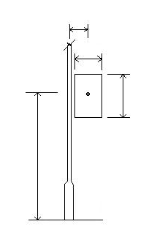
h
d
w
e
GL
Please note: All of the below information will be available from the decoration manufacturer if you do not have it.

Decoration Shape Rectangular:

Circular:

Irregular (provide details);

Sign Weight kg:

Mounting Height (h) meters:

OR; Clearance to Lowest Point meters:

Eccentricity (If known)(if central e = 0) mm:

Sign Depth or Diameter (d) mm:

Sign Width if not Circular (w) mm:

Solidity % (solid = 100%) mm:
Maximum Effective Windage Area m²:

Orientation of attached sign in relation to the lantern:

Under Bracket (0⁰ )

Right angles to Bracket. (90⁰⁾

Opposite Bracket (180⁰⁾

Additional Information:

